Today  
  
**Ariston** 6:01 PM  
Good evening everyone!  
Messages addressed to "meeting group chat" will also appear in the meeting group chat in Team Chat  
  
**ilir** 6:01 PM  
This is for the frontend coding bootcamp correct?  
Deepa joined as a guest  
Nicole H left  
  
**Ariston** 6:02 PM  
Dear Participant,  
  
We kindly invite you to fill out our student information form.  
Your participation is essential to help us tailor our services to better meet your needs.  
Rest assured, your privacy is our utmost priority, and we guarantee the safety and confidentiality of your data.  
We value your time, and we want to assure you that you will only need to complete this form once.  
  
Thank you for taking the time to assist us in enhancing your educational experience.  
Access the Student Information Form here: https://forms.gle/a7QuEfjtcYRxzUa36  
Please join our Slack Channel: https://join.slack.com/t/onecodecampglobal/shared_invite/zt-2klmiqjqs-YaZpIUUiCMA7YbSpgRSzYg  
  
**Deepa** 6:06 PM  
hi, can I fill up form tomorrow?  
Celine joined as a guest  
  
**Ariston** 6:07 PM  
Dear Participant,  
  
We kindly invite you to fill out our student information form.  
Your participation is essential to help us tailor our services to better meet your needs.  
Rest assured, your privacy is our utmost priority, and we guarantee the safety and confidentiality of your data.  
We value your time, and we want to assure you that you will only need to complete this form once.  
  
Thank you for taking the time to assist us in enhancing your educational experience.  
Access the Student Information Form here: https://forms.gle/a7QuEfjtcYRxzUa36  
Please join our Slack Channel: https://join.slack.com/t/onecodecampglobal/shared_invite/zt-2klmiqjqs-YaZpIUUiCMA7YbSpgRSzYg  
  
**Deepa** 6:08 PM  
ok but when I clicked on link my computer firefox needs update  
ohh ok  
  
**You** 6:10 PM  
has to use google account? I don't have one yet

Please join our Slack Channel: https://join.slack.com/t/onecodecampglobal/shared_invite/zt-2klmiqjqs-YaZpIUUiCMA7YbSpgRSzYg

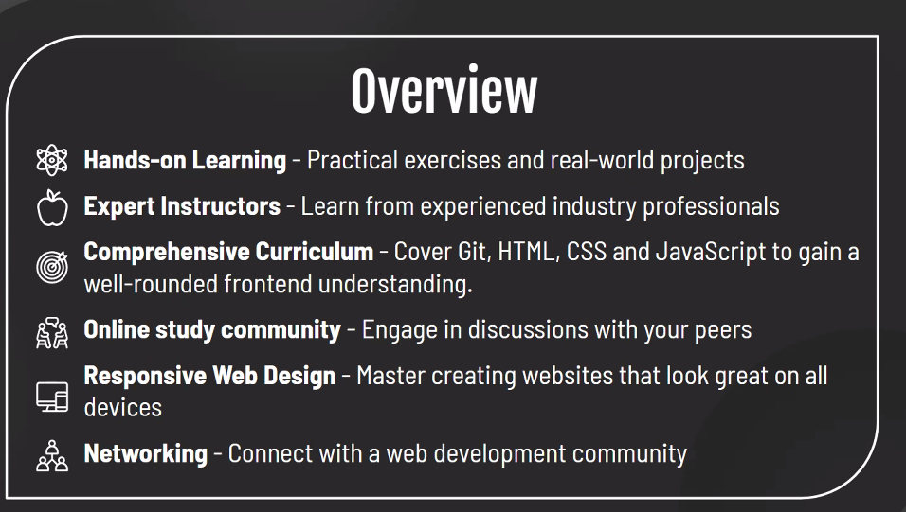

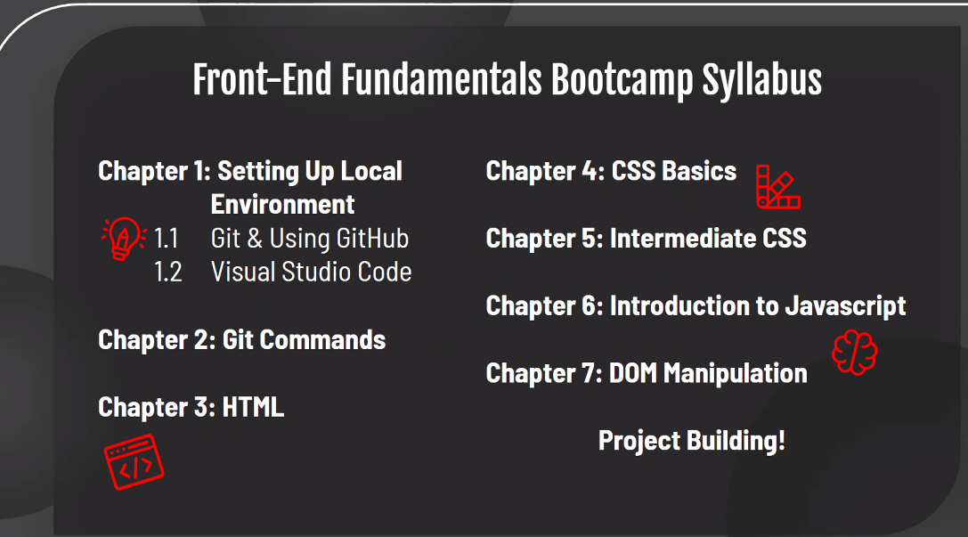

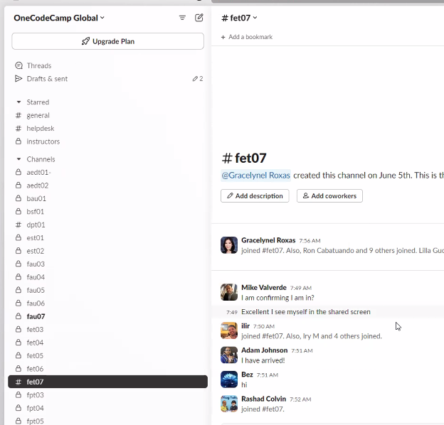

Git: https://git-scm.com/downloads  
VSCode: https://code.visualstudio.com  
GitHub: <https://github.com>

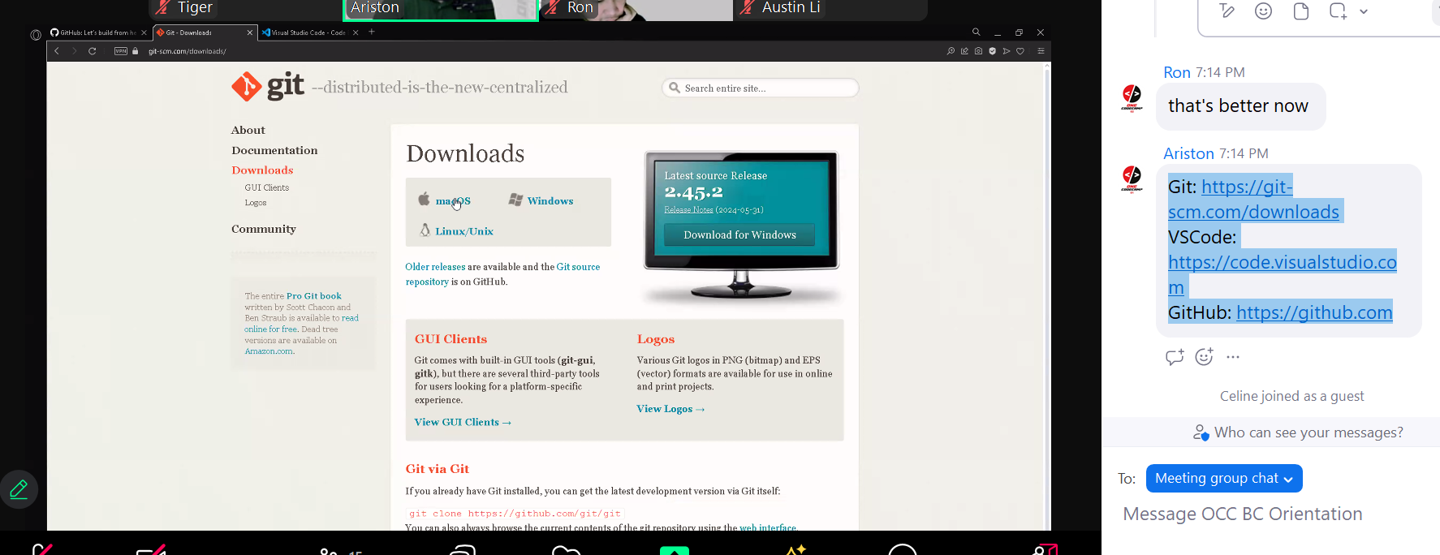

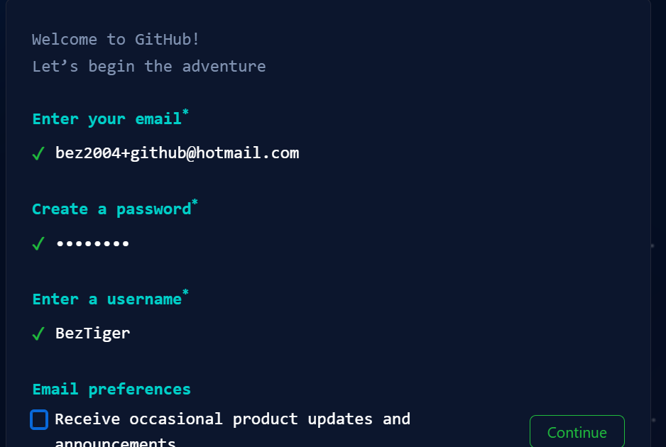

Haode123

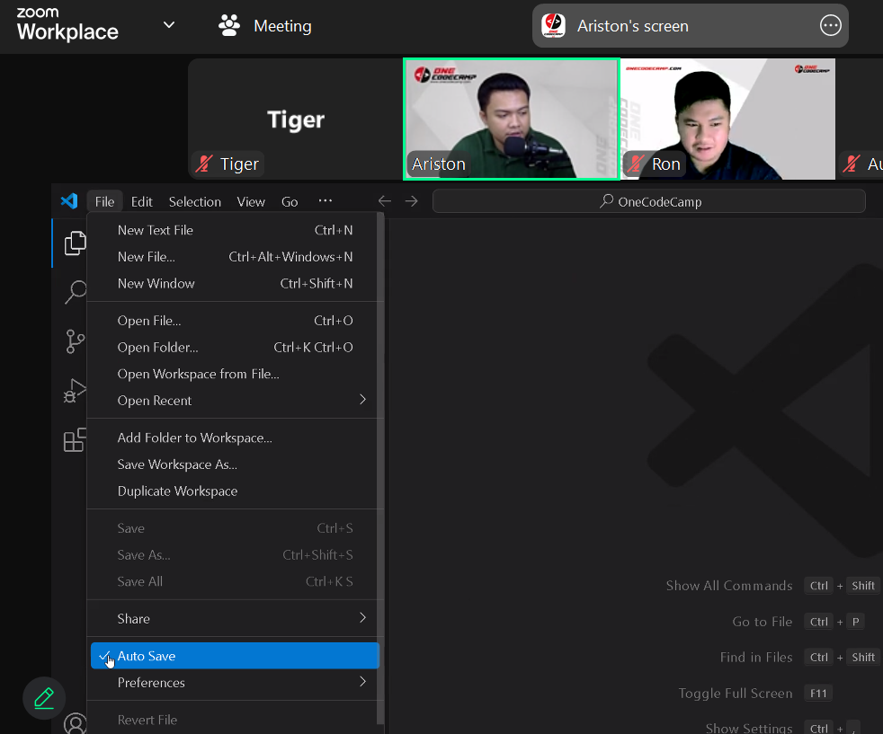

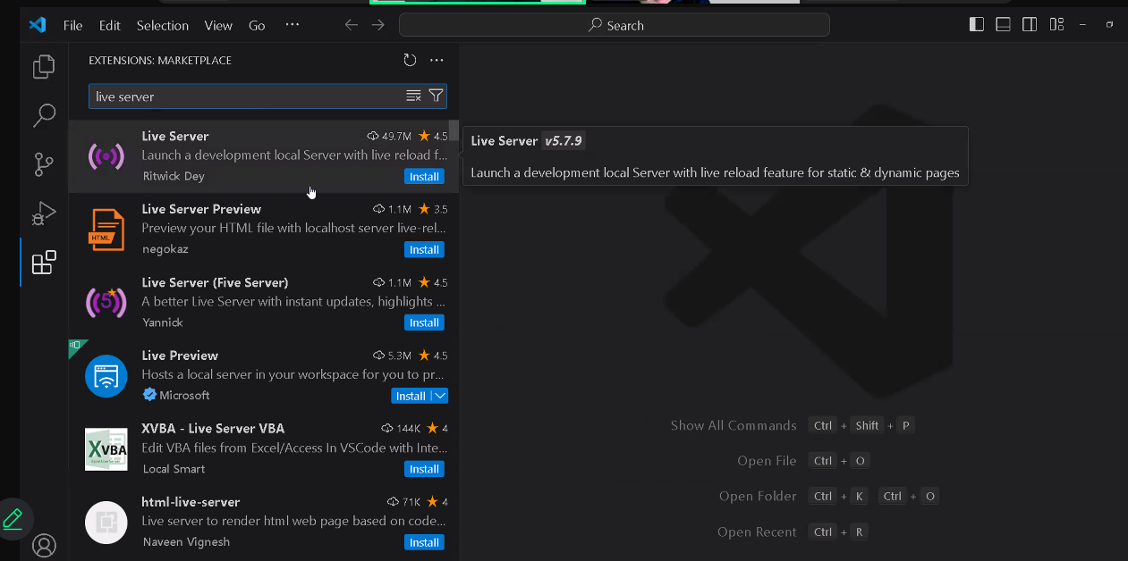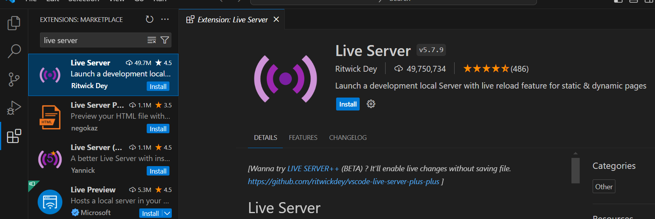

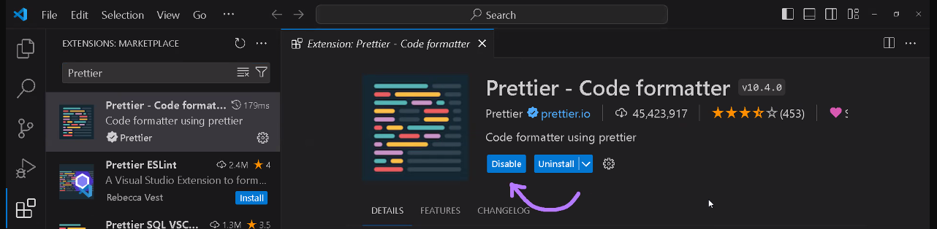

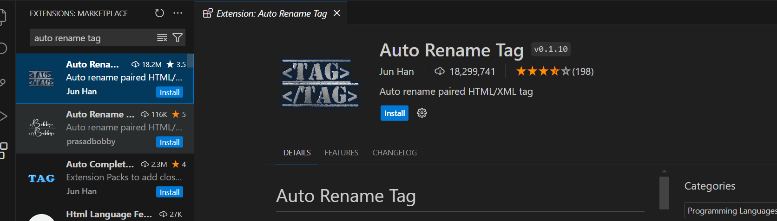

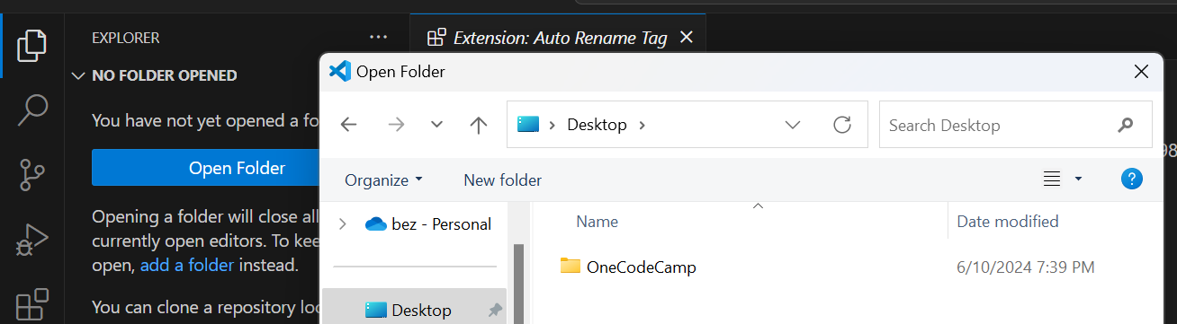

Graphical User Interface (GUI)  
Command-line Interface (CLI)

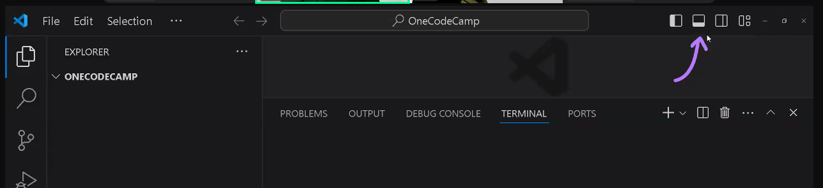

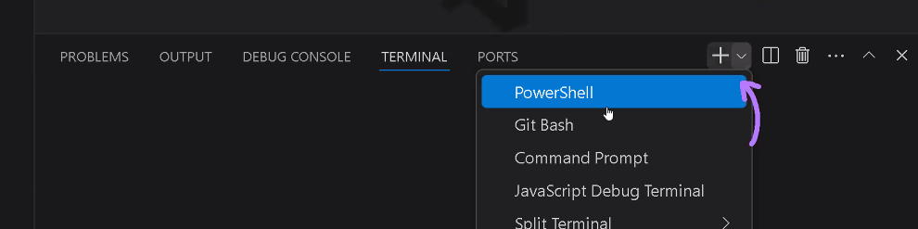

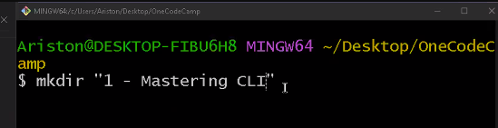

mkdir "1 - Mastering CLI"

mkdir "2 - Git and GitHub"  
mkdir "3 - HTML"  
mkdir "4 - CSS Basics"  
mkdir "5 - Intermediate CSS"  
mkdir "6 - JavaScript"  
mkdir "7 - DOM Manipulation"  
mkdir "8 - Task Manager App"

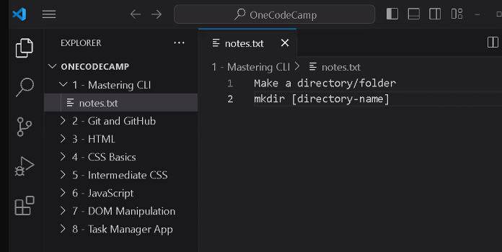

Make a directory/folder  
mkdir [directory-name]  
mkdir test  
Remove a directory  
rmdir [directory-name]

touch [filename.extension]

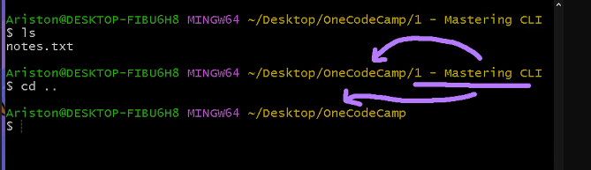

Configure Git, return nothing means success

Command: git config --global user.name "username"

Command: git config --global user.email "email"

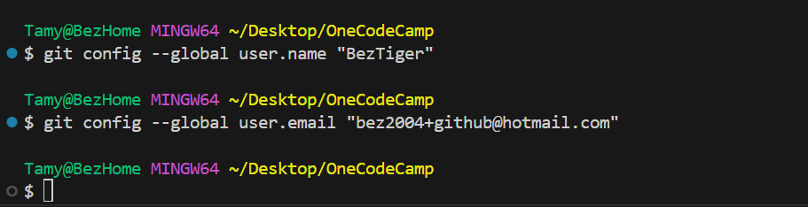

Git init

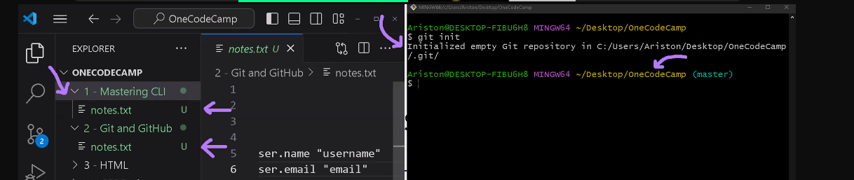

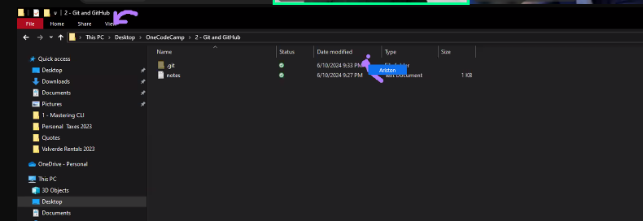

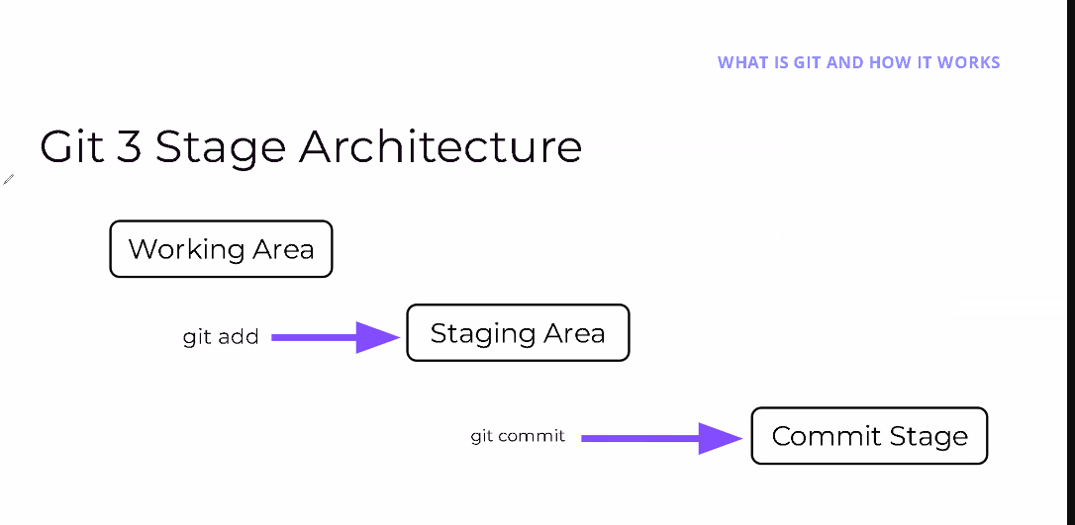

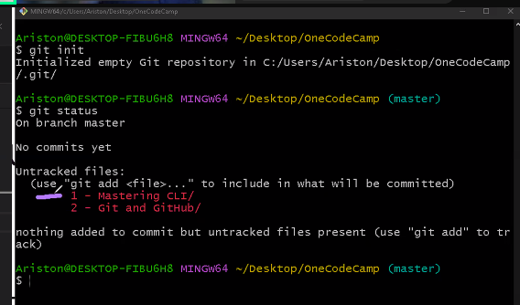

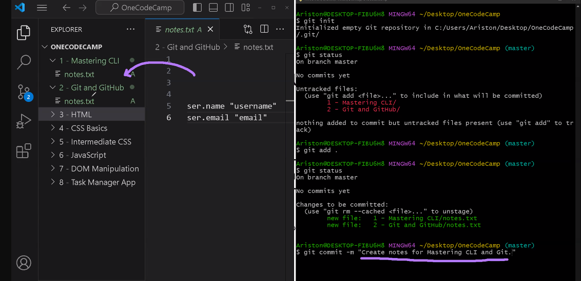

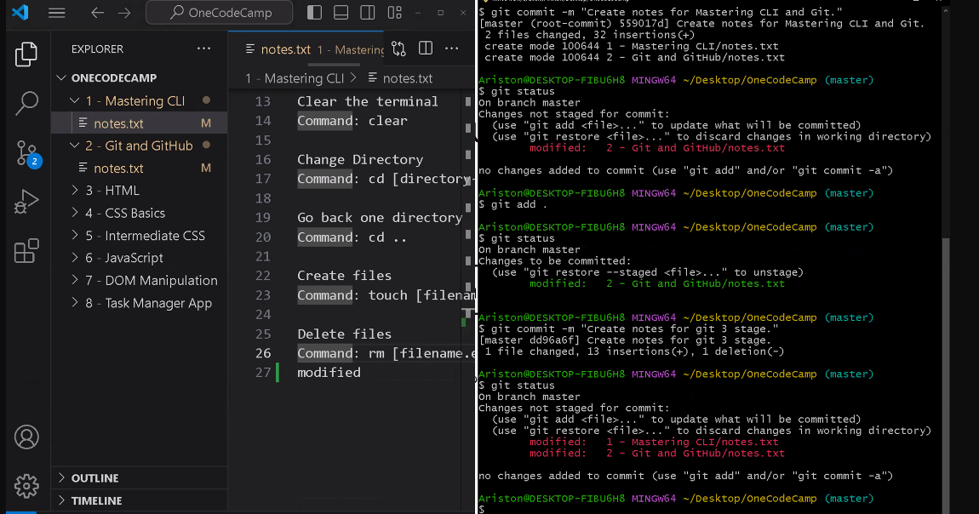

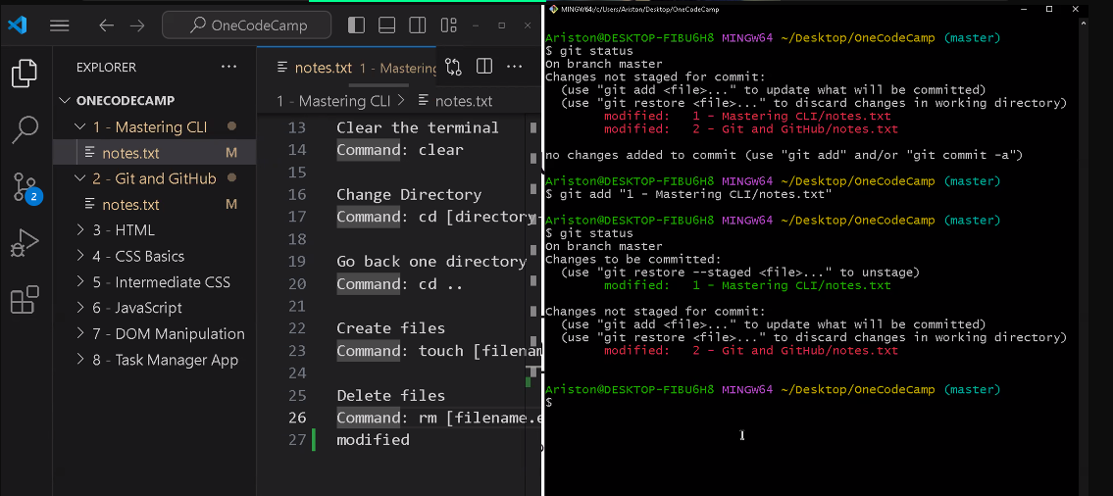

U - Untracked  
M - Modified  
A - Added

Skip staging area using

Git commit -a -m

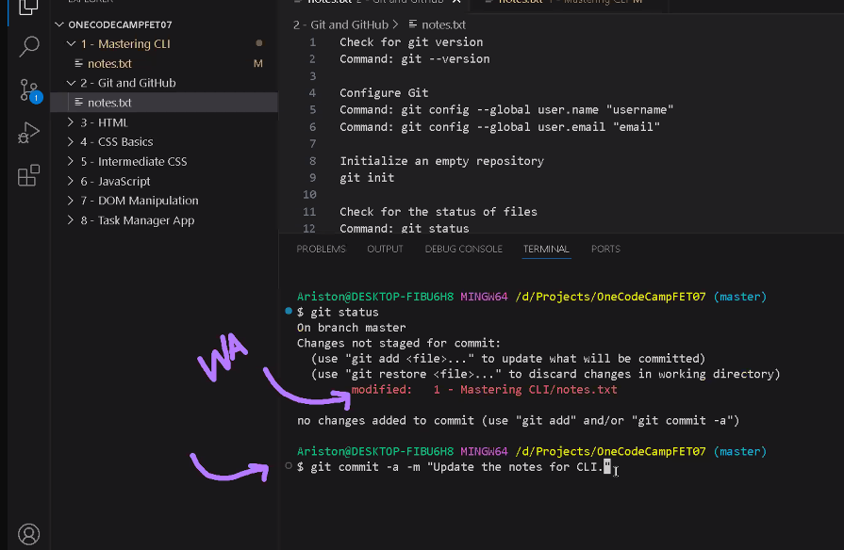

---day 2

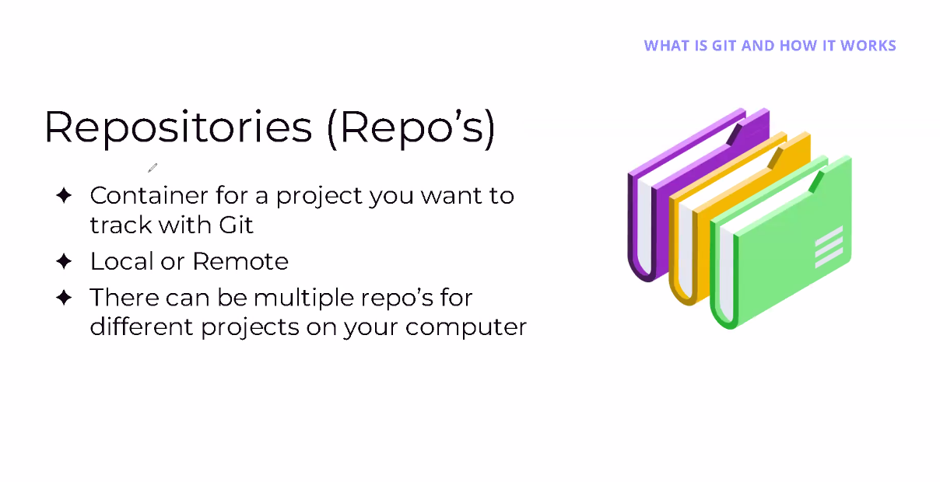

Create new remote repository

<https://github.com>

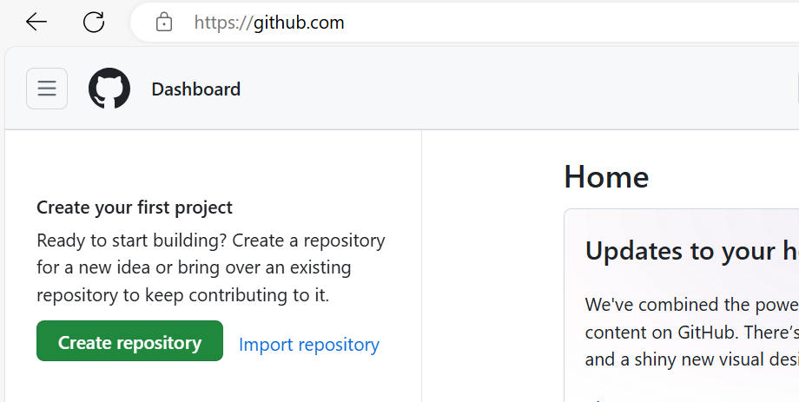

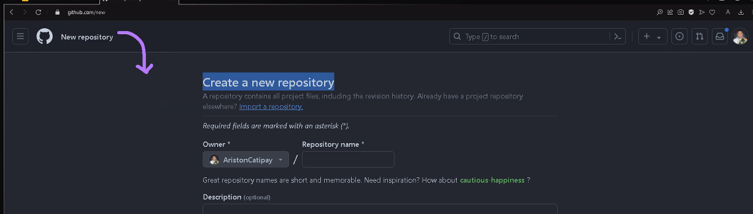

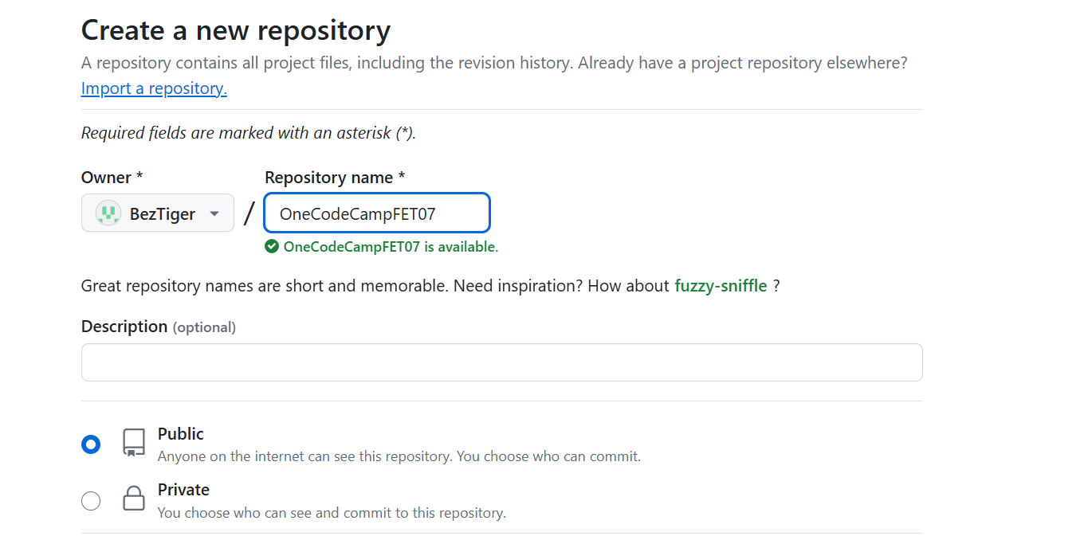

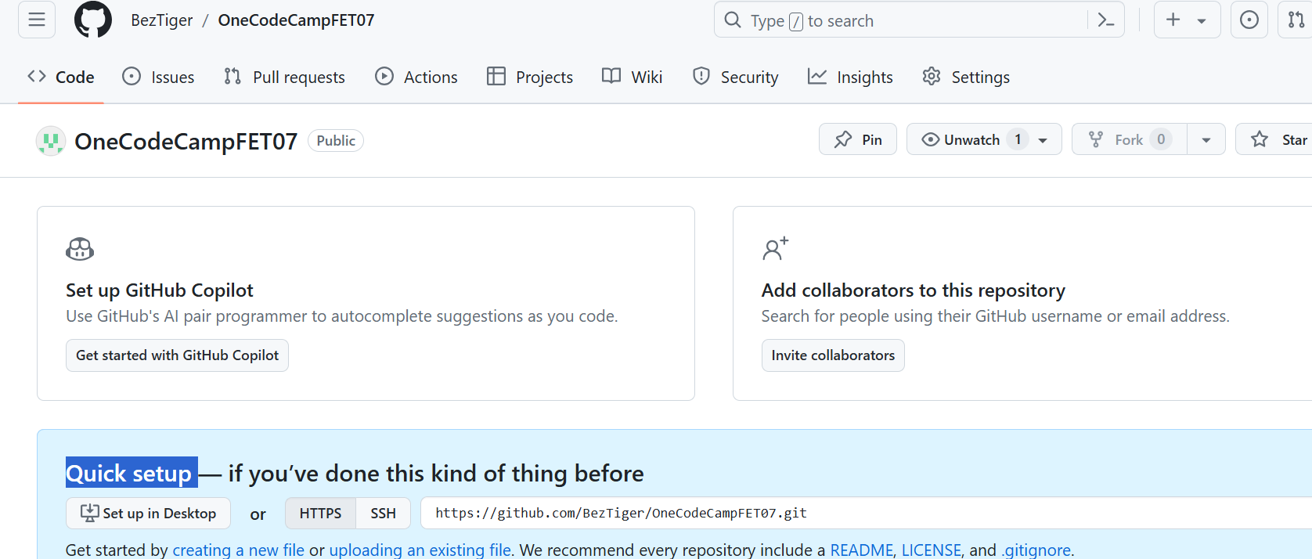

If want change from “public” to private later, you could goto “setting” in above page, and scroll down.

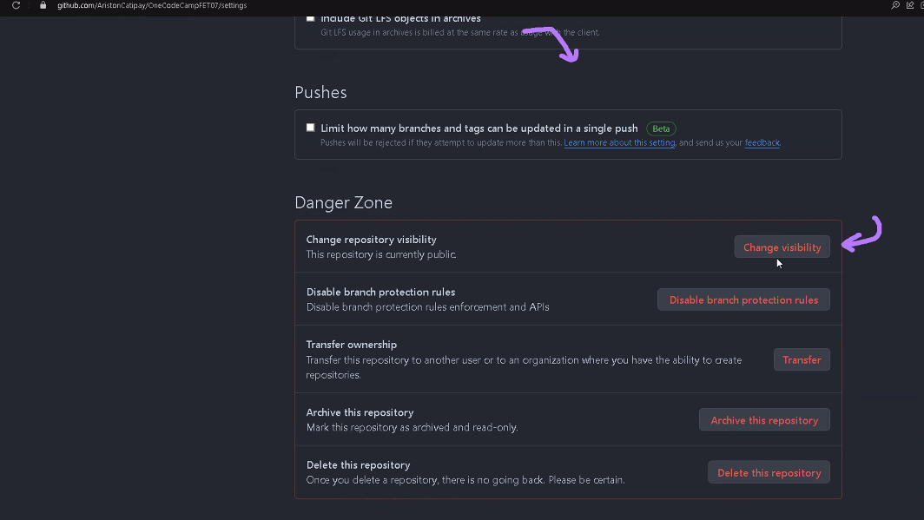

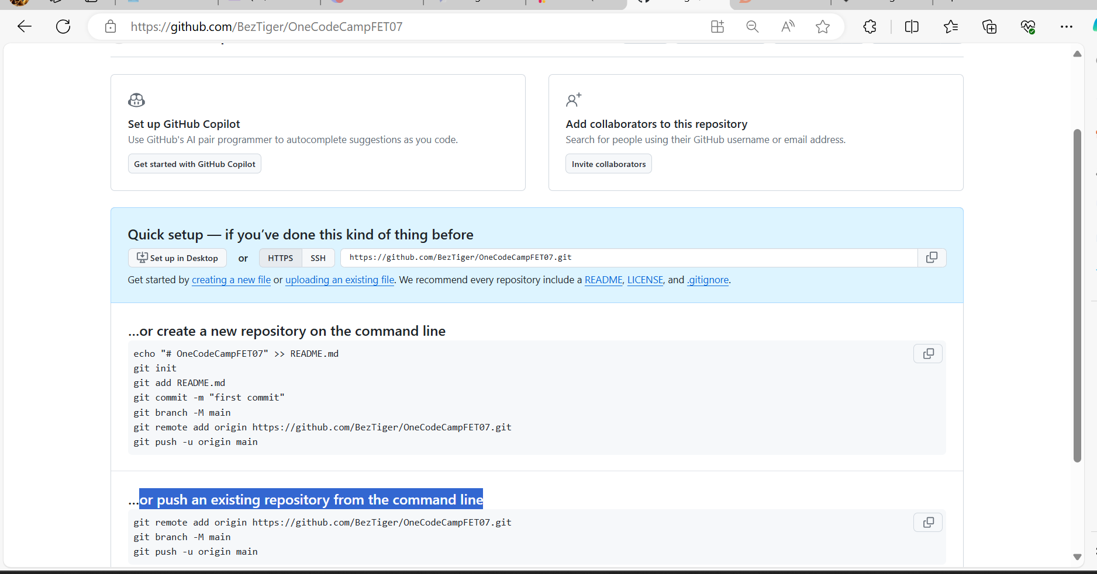

git remote add origin <https://github.com/BezTiger/OneCodeCampFET07.git>

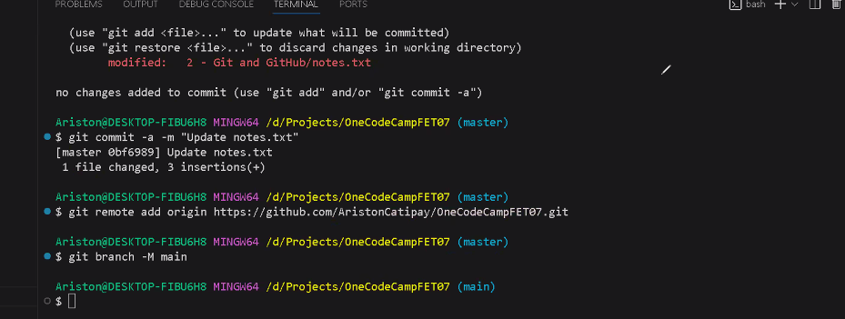

Set up remote main repository

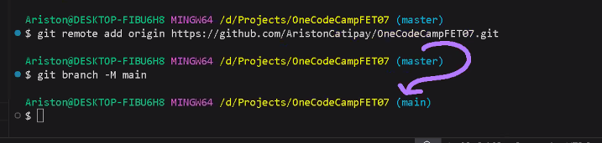

git branch -M main

git push -u origin main

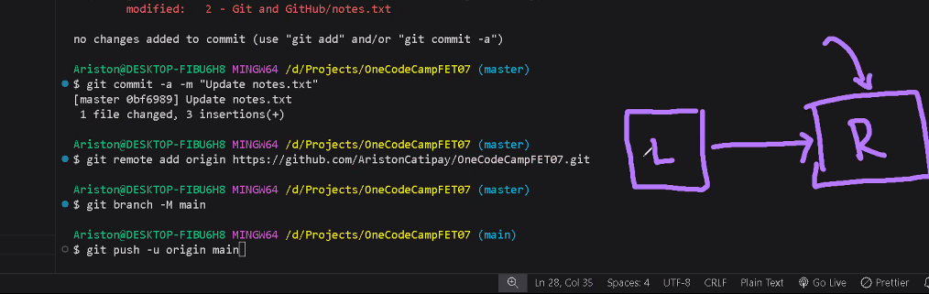

My screen

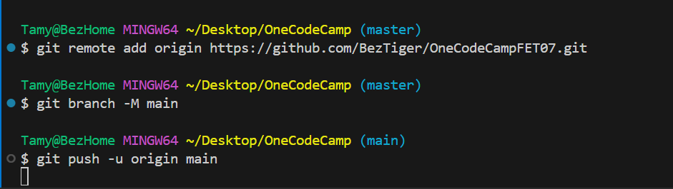

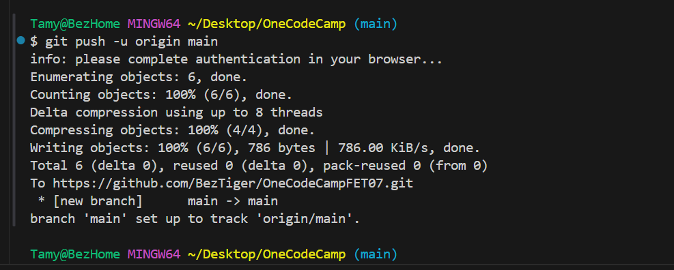

Now , refresh the browser for github.com

You synced your local project folder with the remote repository

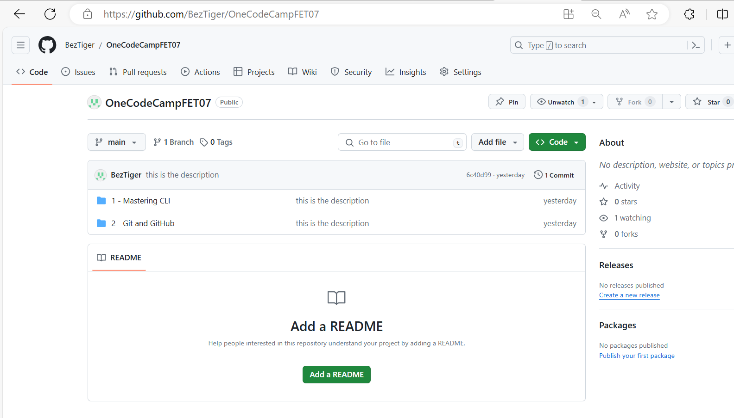

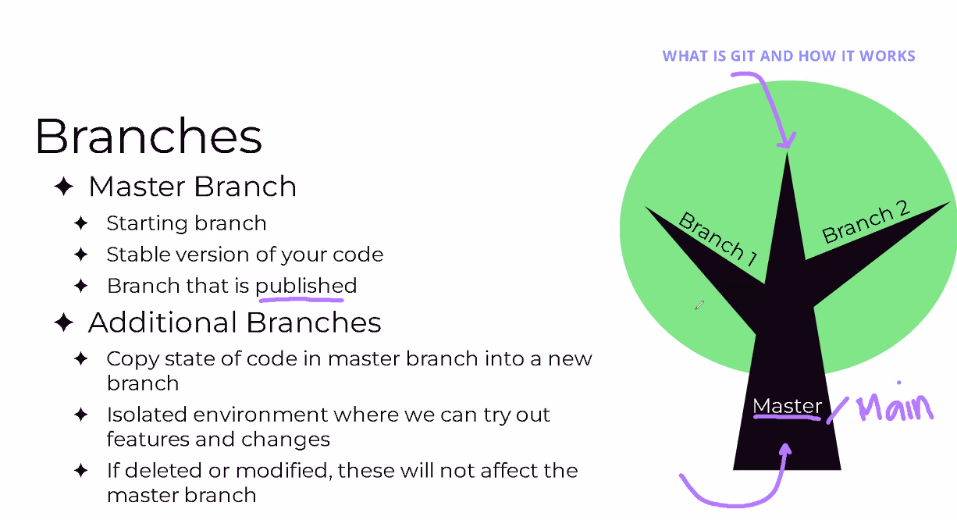

List all of the branches  
git branch -a 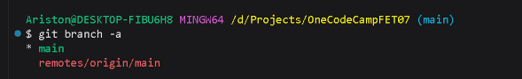

Create a branch named “feature”

git branch feature

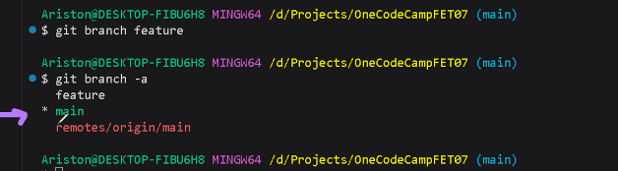

Switch to different branch

git switch feature

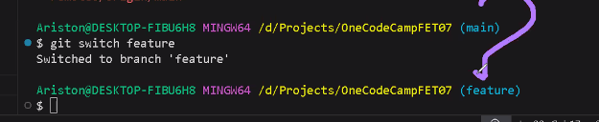

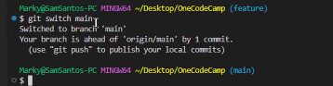

Sync local and main for Sam

Git push

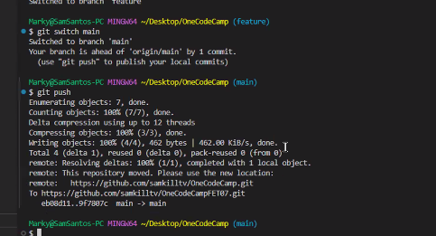

Git log

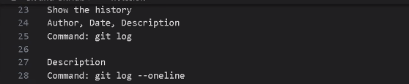

Merge branch “feature” to branch “main”

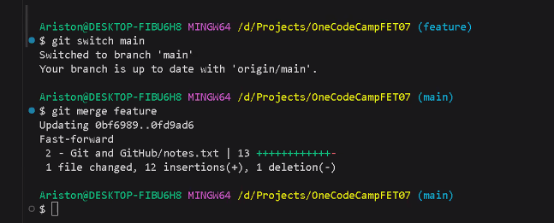

Delete branch

Git branch -d feature

